Census or Sample?
Here are three important definitions:
POPULATION – The entire group of people, animals or things about which we want information.
SAMPLE – A part of the population from which we actually collect information which is used to draw conclusions about the whole population.
CENSUS – This is when every member of the population has data collected from them. Most of the information we are given in number form is taken from samples not from the whole population.
EXAMPLE:
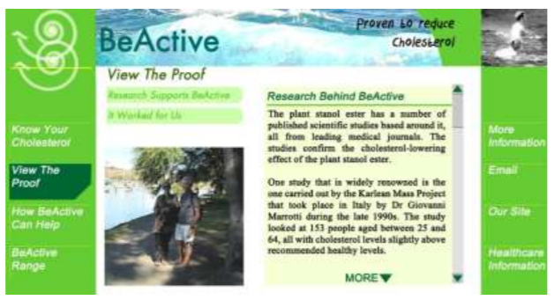
Look at this advertisement – It says “Proven to reduce Cholesterol”, but only 153 people were in the sample it was tested on.
Discuss the size and makeup of this sample (2 marks, so 2 sentences)

Think about each of the following examples. Which of them would you study by sampling and why? How big should your samples be?
Length of battery life

Accurate count of the number of people in the world

Safety of cords on parachutes

The top ten pop songs this week

Reasons for absence from school when the West Coast Eagles are playing in the semi-finals
What might be wrong in using the following samples to describe the Australian Population as a whole?
a) Teenagers

b) People whose names begin with P

c) People using Perth Airport

d) People in restaurants

e) Every tenth person in the telephone directory

